Shopping Mission Interpreter
Structured Intent Parsing for Grocery Shopping Requests
Course: NLP Group Project (Option 1: Application Development)
Idil Ure
Georgi Opnakov

Contents
Abstract
1. Introduction and project need
2. Related work and positioning
3. System design
4. Evaluation methodology
5. Results and discussion
6. Failure analysis
7. Limitations and future work
8. Reproducibility and deliverables
9. Use of AI tools
References

Abstract
This report presents the Shopping Mission Interpreter, a proof-of-concept NLP application for online grocery shopping. The system reads a free-text request such as 'quick dinner without dairy' or 'snacks for a kids party, one child has a nut allergy' and converts it into a structured JSON representation of the shopper's mission, meal occasion, hard dietary constraints, softer preferences, excluded items, suggested aisles, risk flags, confidence and explanation. A second stage uses the interpreted mission to select and rank products from a real retail-style catalogue. The main technical contribution is not simply using an LLM for recommendation but separating intent interpretation from product ranking so that the system can be evaluated, explained and compared against a keyword baseline. On a 50-example hand-labelled test set, the LLM interpreter reaches 0.96 accuracy on meal occasion and 0.957 F1 on dietary constraints, compared with 0.94 and 0.857 for the keyword baseline. The largest gains appear on risk flags (+0.261 F1) and excluded items (+0.250 F1), fields that require semantic inference, negation handling and safety-aware reading. The main limitation is mission type classification, where a single closed label is sometimes too restrictive for real shopping requests with multiple goals.

1. Introduction and project need
Online grocery search is still often built around product keywords. That works when a shopper types 'milk', 'bread' or 'bananas'. It works less well when the shopper describes a situation: 'something healthy but filling after the gym', 'a gluten-free dinner for guests', or 'party drinks but nothing alcoholic because kids will be there'. These requests contain intent, occasion, constraints and risk information, but much of that meaning is lost if the system treats the sentence as a bag of product terms.
Our project targets this gap. The task is: given one free-text shopping request, produce a structured interpretation that a recommendation engine can use safely and transparently. The interpretation must separate hard constraints, such as allergies and intolerances, from softer lifestyle preferences, such as healthy, high-protein or quick. It must also recognize negation and exclusions, because recommending the exact thing a user asked to avoid is one of the most visible failures in a shopping assistant.
The broader motivation and industry landscape are discussed in the accompanying document Need Justification and Field Review. In brief, grocery retailers are moving from simple search and collaborative filtering toward conversational and intent-aware shopping. Instacart's Ask Instacart and Carrefour's Hopla assistant point in the same direction: retailers increasingly want systems that understand shopping goals, not just product names. Our contribution is a small but evaluable version of that idea: an intent-understanding layer placed before recommendation, with a clear schema and measured errors.
The proof of concept is deliberately modest. It is not a production retail assistant and it does not claim to solve nutrition or inventory. Instead, it demonstrates the NLP layer that would sit between a customer request and a downstream recommender. The emphasis is on technical clarity: a shared schema, a keyword baseline, an LLM interpreter, a custom test set and a failure analysis grounded in our own outputs.

2. Related work and positioning
This project sits between task-oriented dialogue, information extraction and recommender systems. In task-oriented dialogue, a user utterance is commonly decomposed into an intent and slots. Classic datasets such as ATIS framed this problem for travel requests, while later work used neural and pre-trained language models for joint intent detection and slot filling. Our shopping schema follows the same logic: the user's sentence is not the final answer, but evidence from which structured fields are extracted.
The second relevant area is conversational recommendation. Unlike conventional recommender systems, which often start from historical behaviour or item similarity, conversational recommenders need to interpret what the user wants in the current moment. This is especially important in grocery because shoppers often buy for different missions: weekday replenishment, a party, a health goal, a child's lunchbox, or a specific recipe. The same user can need very different baskets depending on context.
Large language models make this kind of interpretation easier because they can infer implicit meaning. For example, 'celiac' implies a gluten-free requirement even if the word gluten is never used, and 'diabetic' suggests a low-sugar preference and a safety flag. However, LLM outputs can be hard to evaluate if they are free-form. We therefore use schema-constrained prompting: the model must return a fixed JSON object, while still producing a short summary and explanation. This gives us a middle ground between rigid rule-based extraction and unconstrained generation.
Retail search research also motivates the project. Embedding-based grocery search systems improve retrieval by matching semantic similarity rather than exact words. That is useful, but it does not fully solve the interpretability problem: the system may retrieve better products without exposing whether it understood an allergy, a negation or a budget constraint. Our system makes that intermediate interpretation visible and scoreable before products are suggested.

3. System design

3.1 Architecture
The application uses a two-stage pipeline. The first stage reads the request and produces the structured mission. The second stage uses that mission to rank catalogue products. Keeping these stages separate was an intentional design choice. If one LLM call directly returns products, it is difficult to know whether errors come from intent misunderstanding, product selection, or both. With a separate interpretation layer, we can evaluate the NLP task field by field.
Pipeline overview:
Free-text shopping request
↓
Stage 1: Intent Parser
- keyword_interpreter.py (baseline)
- llm_interpreter.py (gpt-4o-mini)
↓
Structured mission JSON
↓
Stage 2: Product Recommender
- product_recommender.py
- product_index.json from Instacart product/aisle data
↓
Streamlit interface with explanations, confidence and feedback
The Streamlit front end lets users enter a shopping request, select the interpreter mode and view the output as cards. The interface displays the mission summary, dietary constraints, preferences, excluded items, suggested aisles, risk flags, confidence and product recommendations. It also includes a feedback component that writes user ratings and comments to a CSV file, providing a simple path for user evaluation.

3.2 Output schema
The schema is the core design object of the project. It was defined before evaluation. The fields are intentionally practical: they represent the kind of information an online grocery platform would need before recommending products.
Field | Type | Purpose
meal_occasion | Single label | Breakfast, lunch, dinner, snack or none.
mission_type | Single label | Main shopping mission: convenience meal, health goal, party hosting, kids meal, household stock-up, specific ingredient or unclear.
budget_sensitivity | Single label | Low budget, medium, premium or not mentioned.
dietary_constraints | Closed list | Hard constraints: nut allergy, lactose-free, gluten-free, vegetarian, vegan, halal.
preference_constraints | Closed list | Softer preferences such as quick, healthy, filling, low sugar or high protein.
product_categories | Closed list | Coarse grocery aisles used for product candidate retrieval.
risk_flags | Closed list | Signals such as allergy/safety, negation, conflicting goals, ambiguity or missing information.
excluded_items | Open list | Literal items the user negated, such as eggs, alcohol or soy.
mission_summary, confidence, explanation | Model output | Human-readable summary, confidence score and one short reason.

The most important distinction is between dietary_constraints and preference_constraints. Allergies, intolerances and diet identities are treated as hard constraints. Goals like healthy or high protein are useful, but they are not the same kind of requirement. This separation makes the output safer and easier to inspect.

3.3 Keyword baseline
The keyword baseline represents a simple alternative to the LLM. It uses hand-written rule tables for each field. For single-label fields, the first matching rule wins; for list fields, all matching rules can fire. Negation is handled through a small set of patterns such as 'no', 'not', 'without' and 'avoid'. This baseline is intentionally transparent. Its role is not to be state of the art, but to show what is gained when the system moves from surface matching to semantic interpretation.

3.4 LLM interpreter
The LLM interpreter uses gpt-4o-mini with temperature set to 0 for reproducibility, JSON mode to keep the output parseable, and a token cap to control cost. The system prompt injects the allowed values from the schema, which reduces drift between the prompt, the code and the evaluation labels.
The prompt focuses on the behaviours most likely to matter in grocery: hard vs. soft constraints, implicit medical or dietary terms, negation, risk flags and neutral values when a field is not stated. Two few-shot examples are included. One teaches the model that 'celiac' implies gluten_free. The other teaches that 'nothing alcoholic' should both add alcohol to excluded_items and remove the alcohol aisle from recommendations. These examples were chosen because they cover the most important failure types rather than because they make the prompt look longer.

3.5 Product recommender
The second stage takes the structured mission and gathers candidate products from the aisles predicted in product_categories. The product index is built from the Instacart product and aisle files. Instacart's detailed aisles are mapped into 14 coarser Carrefour-style aisles, and up to 120 products are kept per aisle to maintain variety without sending the full catalogue to the model.
Before the LLM ranks products, a lightweight safety filter removes obviously incompatible candidates. For example, if nut_allergy is present, products containing terms such as almond, peanut or cashew are removed. This filter is not enough for production safety, but it demonstrates an important design principle: hard constraints should be enforced before a generative model is asked to be creative. The recommender then returns up to eight products, each with a short reason and a match score from 1 to 10. We treat these scores as ranking signals, not calibrated probabilities.

3.6 Example output visuals
Example 1 Request: Birthday food and drinks for kids:
Model automatically understand that the output must be kid friendly and does not recommend alcoholic beverages.
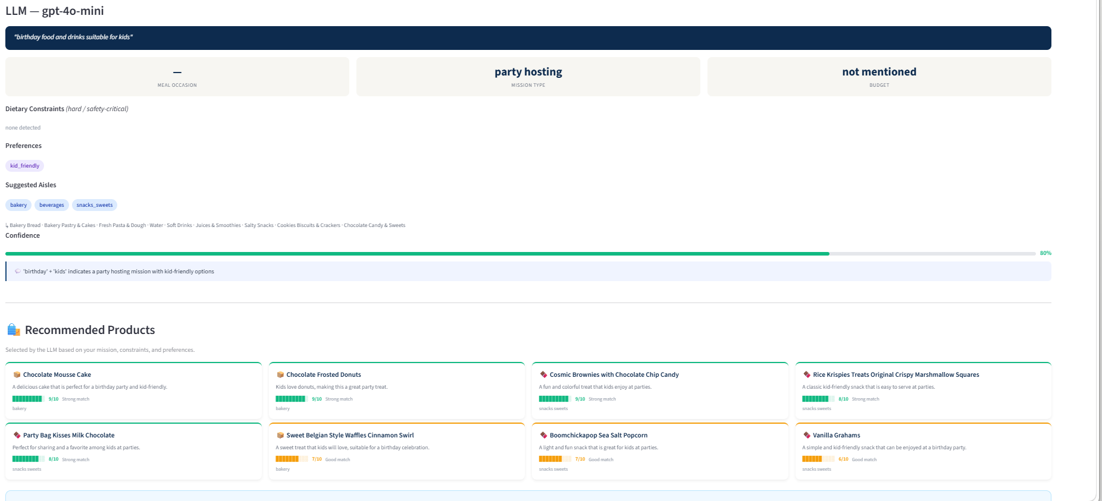
Example 2 Request: Quick halal meal options with meat
Model understand that it shouldn’t recommend any pork product and instead recommends chicken.
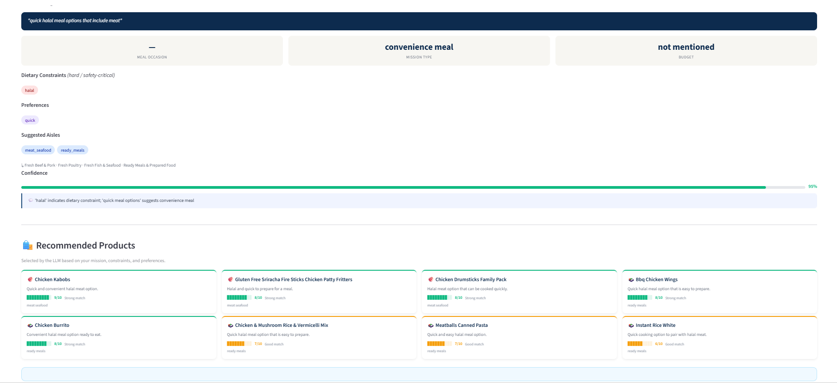

4. Evaluation methodology

4.1 Test set construction
The custom evaluation set contains 50 hand-labelled shopping requests across three tiers.
Tier | Count | Design purpose
Easy | 16 | Explicit and literal requests, where keyword matching should usually work.
Medium | 18 | Requests requiring light inference of mission, preference or category.
Hard | 16 | Negation, conflicting goals, implicit safety constraints or ambiguous wording.

The tier structure is useful because a single overall score can hide where a system actually improves. A grocery assistant does not need an LLM to identify the word breakfast, but it may need one to infer that 'celiac' is a gluten-related safety constraint or that 'nothing alcoholic' should remove an aisle.

4.2 Metrics
Single-label fields are scored with accuracy because each request has one expected value. List fields are scored with micro-F1 because each field can contain zero, one or multiple labels. Micro-F1 penalises both false positives and false negatives at label level, which is more appropriate than exact-match accuracy for lists such as preferences or risk flags. Product categories are included in the metrics but interpreted with caution, because vague requests may reasonably map to more than one aisle.
The free-text mission_summary and explanation are not scored automatically. They are used in the qualitative failure analysis to understand whether the model's interpretation is sensible even when a closed label is imperfect.

5. Results and discussion

5.1 Headline results
Field | Metric | Keyword | LLM | Delta
meal_occasion | Accuracy | 0.940 | 0.960 | +0.020
mission_type | Accuracy | 0.460 | 0.620 | +0.160
budget_sensitivity | Accuracy | 1.000 | 1.000 | +0.000
dietary_constraints | F1 | 0.857 | 0.957 | +0.100
preference_constraints | F1 | 0.772 | 0.786 | +0.014
product_categories | F1 | 0.514 | 0.618 | +0.104
risk_flags | F1 | 0.450 | 0.711 | +0.261
excluded_items | F1 | 0.750 | 1.000 | +0.250

The LLM does not transform every field. It improves most clearly where language understanding is actually needed. Budget sensitivity is perfect for both systems because the relevant words are explicit in the test set. Meal occasion is also almost solved by keywords. This is a useful finding: not every component of a retail NLP system needs a language model.
The strongest LLM gains are on risk_flags and excluded_items. These fields require the system to recognise why a request is linguistically or practically risky. A phrase such as 'healthy but indulgent' is not just a preference list; it expresses tension between goals. Similarly, 'nothing alcoholic' is not merely a beverage query; it is a negation that should block an aisle. The keyword baseline can catch some trigger words but does not reason over the sentence as a whole.
Dietary constraints also improve, from 0.857 to 0.957 F1. This matters more than the raw number suggests, because a missed allergy or intolerance is a higher-stakes error than a missed preference. The LLM's advantage comes from implicit constraint inference: it can connect terms like celiac or diabetic to the relevant shopping implications even when the label words do not appear directly.

5.2 Per-tier reading
Field | Easy | Medium | Hard
meal_occasion KW/LLM acc | 0.88 / 0.94 | 1.00 / 1.00 | 0.94 / 0.94
mission_type KW/LLM acc | 0.00 / 0.50 | 0.61 / 0.78 | 0.75 / 0.56
dietary_constraints KW/LLM F1 | 0.00 / 0.00 | 1.00 / 1.00 | 0.77 / 0.93
risk_flags KW/LLM F1 | 0.00 / 0.00 | 0.22 / 0.18 | 0.52 / 0.88
excluded_items KW/LLM F1 | 0.00 / 0.00 | 0.00 / 0.00 | 0.75 / 1.00

The hard tier is the most informative. The LLM reaches 0.88 F1 on hard-tier risk flags compared with 0.52 for the keyword baseline, and it reaches 1.00 F1 on excluded items compared with 0.75. This supports the main claim of the project: the LLM is most useful on cases involving negation, implicit safety constraints and conflicting goals.
The mission_type result needs a careful reading. The LLM improves the overall score from 0.46 to 0.62, but the hard-tier score is lower than the baseline. This does not mean the LLM is worse at understanding the request. In many cases, the LLM summary captures the nuance while the single mission_type field forces one label onto a request that contains multiple goals. This is a schema limitation and an important design lesson.

6. Failure analysis
We reviewed failures not only to list mistakes, but to understand what kind of NLP problem each mistake represents. For a more deepdive failure analysis we have a separated analysis called Failure_analysis_deepdive submitted along with this report. Table 5 documents eight representative failures or unexpected behaviors from the evaluation outputs, with hypotheses about why they occurred and what would improve the system.
Case | System | Failed field(s) | Observed behaviour | Hypothesis / improvement
Birthday cake but my daughter is celiac | Keyword | dietary_constraints; risk_flags | The baseline returns no gluten_free constraint and no allergy_or_safety flag because the word 'gluten' is absent. | Keyword rules cannot infer medical/dietary implications. Add explicit celiac rules or use the LLM interpretation for safety-critical fields.
Quick dinner, nothing with dairy though | Keyword | dietary_constraints; excluded_items; risk_flags; product_categories | The baseline misses lactose_free, dairy exclusion and the ready-meal category. | Negation and category inference are too shallow. Improve negation parsing and map 'dairy' to lactose-related safety handling.
Party drinks but nothing alcoholic, kids will be there | Keyword | excluded_items; product_categories in similar negation cases | The baseline can notice some negation words but does not reliably remove the alcohol aisle or preserve the beverage mission. | Category removal requires sentence-level interpretation, not independent keyword hits. Add exclusion-aware category filtering.
Something healthy but I still want it to feel indulgent | Both | mission_type; product_categories; risk_flags | The request expresses conflicting goals. The LLM captures some nuance, but the closed mission_type field can still become unclear. | Single-label mission_type is too restrictive. Allow multiple mission labels or a separate conflict/tension field.
Dinner my vegetarian sister and my meat-loving dad will both eat | Both | mission_type; product_categories | The request involves multiple people with competing needs, and product_categories are hard to infer from the sentence alone. | Represent sub-missions or ask a follow-up question. Catalogue context is needed for bridge products such as plant-forward mains.
Breakfast but not eggs, I can't stand them | LLM | mission_type; product_categories | The LLM identifies breakfast and egg exclusion but under-predicts alternative breakfast categories such as bakery. | The model handles negation better than category expansion. Add retrieval examples or rules that suggest substitutes when a common item is excluded.
Snacks for the kids, but one of them is allergic to nuts | LLM | preference_constraints; product_categories | The LLM preserves the nut-allergy safety issue but misses kid_friendly and one expected aisle. | Safety dominates the interpretation, causing softer preferences/categories to be under-specified. Prompt for both safety and ordinary shopping intent.
Get the usual | LLM | risk_flags | The LLM marks ambiguity but omits missing_information, even though the request cannot be acted on without history. | Ambiguous requests should trigger both ambiguity and missing-information flags, followed by a clarification question.

The most practically important failures are safety-related. Missing celiac or diabetic implications is not just a classification mistake; it could lead to a harmful recommendation if the product stage trusted the interpretation blindly. This is why the schema separates hard constraints from soft preferences and why the product recommender includes a first-pass safety filter. A related product-level limitation appears when the recommender reasons from names only: for a diabetic breakfast request, a granola bar can look healthy from wording even when nutrition facts might say otherwise.
The most conceptually interesting failures involve mission_type and product_categories. Requests such as 'dinner my vegetarian sister and meat-loving dad will both eat' are not cleanly one mission; they are multi-person negotiations. A single closed label is useful for scoring, but not always faithful to the language. A better future design would allow multiple mission labels, sub-missions, or follow-up questions when confidence is low.

7. Limitations and future work
The first limitation is dataset size. Fifty examples are enough for a course project and for comparing two versions of the same system, but not enough to claim general retail performance. The test set is also English-only and deliberately constructed, so it does not fully capture open-world shopping language.
The second limitation is product knowledge. The recommender sees product names and aisle labels, not ingredients, allergens, nutrition facts, prices or real-time availability. This is acceptable for a proof of concept but not enough for health-related recommendations. The clearest next step would be to connect the product stage to a nutritional database such as Open Food Facts or to a retailer's structured product metadata.
The third limitation is the single-turn setting. In real shopping, the safest response to a vague or risky request may be to ask a follow-up question. For example, if a user says 'something healthy for my dad', the system may need to know whether there are medical constraints, budget constraints or flavour preferences. Confidence scores and risk flags could be used to decide when the assistant should ask rather than recommend.
Future work follows directly from these limitations: multilingual evaluation, better confidence calibration, RAG over a retailer catalogue, nutritional and allergen validation, inventory-aware recommendations, and a larger user study using the feedback collected by the Streamlit app. In a retailer context such as Carrefour, Tesco or Sainsbury's, the interpreter could also be combined with loyalty data, but only if privacy and transparency are handled carefully.

8. Reproducibility and deliverables
The project is organised as a reproducible repository. The main application is app.py. The LLM interpreter is implemented in llm_interpreter.py, the product ranking stage in product_recommender.py, the shared schema validation in schema_utils.py, and the product index builder in build_product_index.py. The system expects the schema and category mapping files in the data directory and writes feedback and evaluation outputs to results.
The repository should be submitted together with requirements.txt, README.md, SETUP.md, USER_MANUAL.md, the evaluation set, prompts, product-index construction script and result files. This matches the assignment requirement that the system be reproducible rather than only shown as a demo. The separate Need Justification and Field Review document should be submitted as a supporting artifact rather than repeated at length in the main report.

9. Use of AI tools
AI tools were used during the project for coding support, debugging, prompt drafting, report editing and documentation scaffolding. The team retained ownership of the substantive decisions: the project framing, schema design, label definitions, evaluation examples, gold labels, choice of metrics, interpretation of results and final failure analysis. The use of AI assistance was therefore similar to normal development support, not a replacement for the team's judgement. Team members should be able to explain the schema, the prompt, the baseline, the evaluation metrics and the main failure cases.

References
Carrefour. (2023). Carrefour integrates OpenAI technologies and launches a generative AI-powered shopping experience. https://www.carrefour.com/en/news/2023/carrefour-integrates-openai-technologies-and-launches-generative-ai-powered-shopping
Gao, C., Lei, W., He, X., de Rijke, M., & Chua, T.-S. (2021). Advances and challenges in conversational recommender systems: A survey. AI Open, 2, 100-126.
Hemphill, C. T., Godfrey, J. J., & Doddington, G. R. (1990). The ATIS spoken language systems pilot corpus. Proceedings of the DARPA Speech and Natural Language Workshop, 96-101.
Instacart. (2023). Bringing inspirational, AI-powered search to the Instacart app with Ask Instacart. https://company.instacart.com/updates/bringing-inspirational-ai-powered-search-to-the-instacart-app-with-ask-instacart
Ouyang, L., Wu, J., Jiang, X., Almeida, D., Wainwright, C. L., et al. (2022). Training language models to follow instructions with human feedback. NeurIPS 2022.
Xie, Y., Na, T., Xiao, X., Manchanda, S., Rao, Y., Xu, Z., Shu, G., Vasiete, E., Tenneti, T., & Wang, H. (2022). An embedding-based grocery search model at Instacart. arXiv:2209.05555.

